**Part – A**

1. Consider an undirected graph as shown in figure – 1.

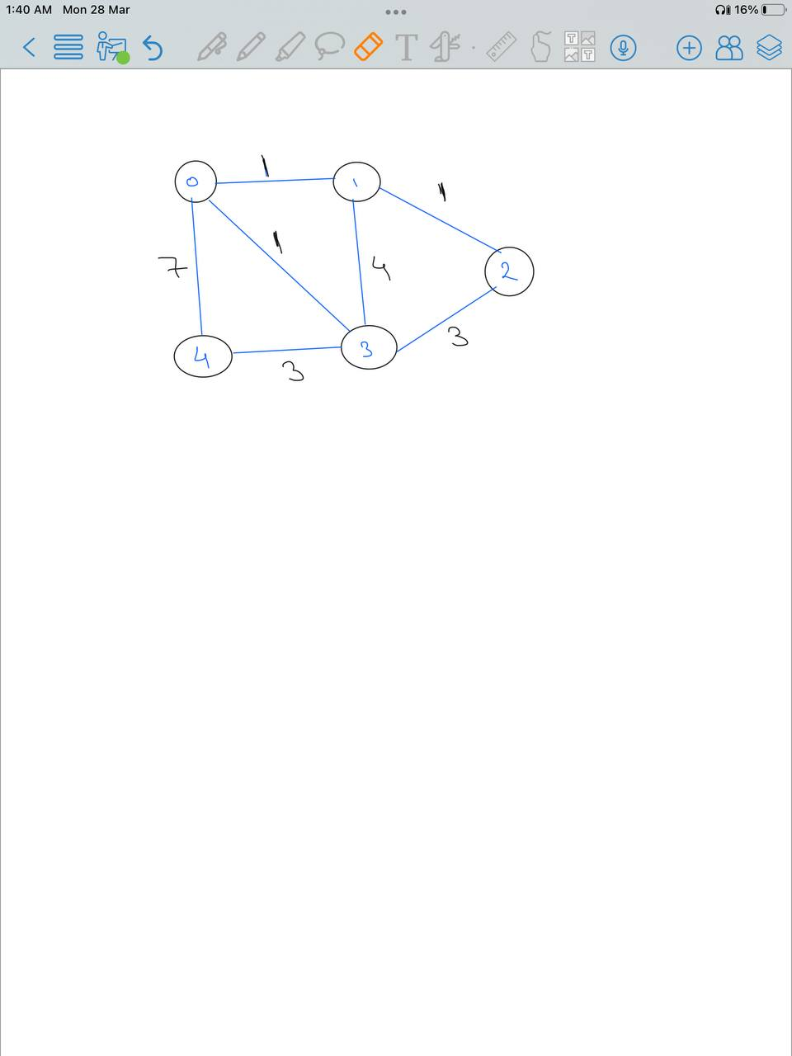

**Figure- 1**

Applying the greedy algorithm consider vertex – 0 as the starting vertex, we get a minimum spanning tree with cost 8 as shown in figure -2(a), while the actual minimum spanning tree will be of cost 6 as shown in figure -2(b).

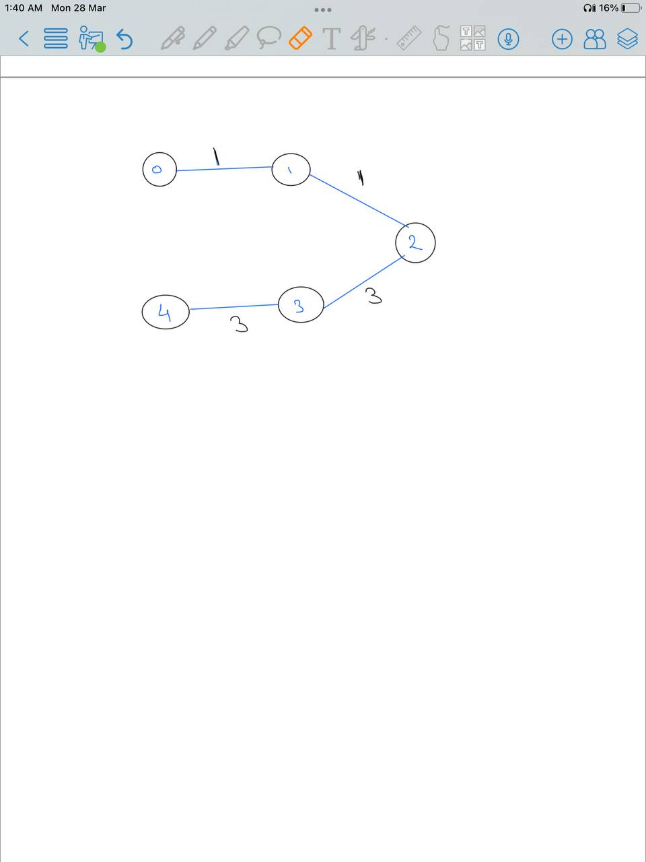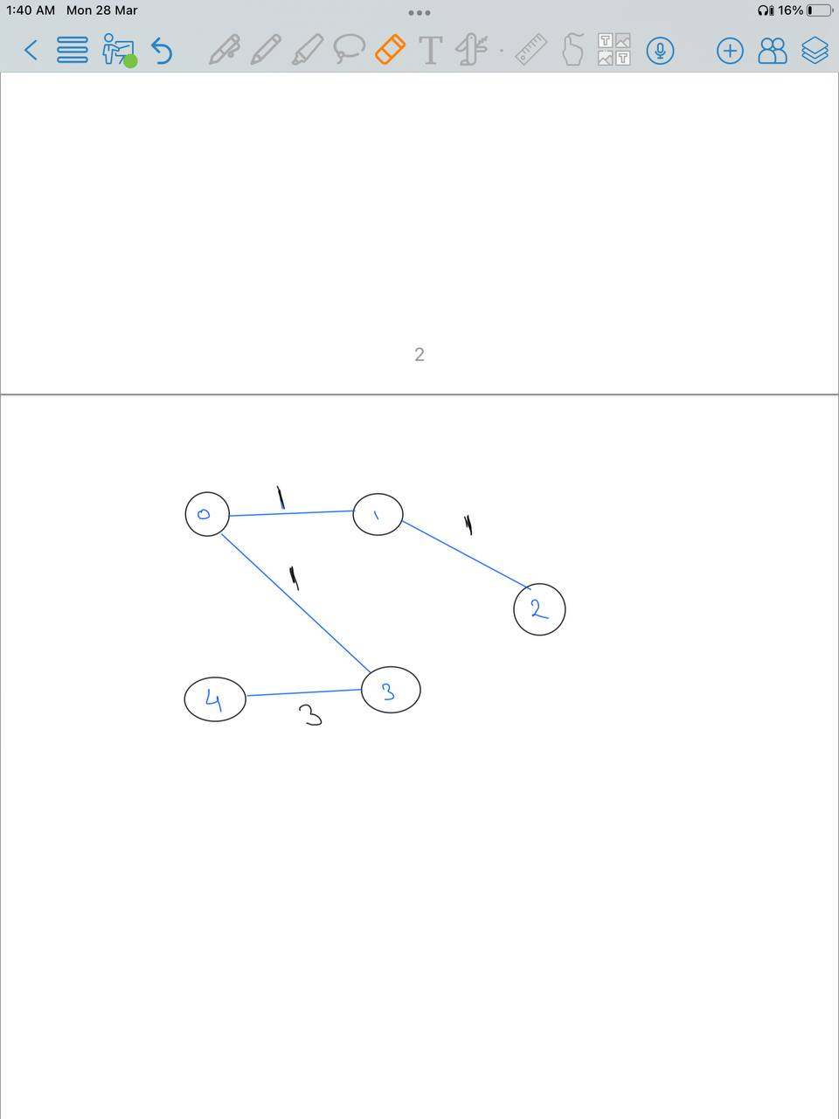

**Fig. 2(a)(left) the minimum spanning tree from greedy solution (b)(right) the optimal solution**

1. Consider a set A of 10 animals with each animal represented as an integer from 1-10.  
   A = {1, 2, 3, 4, 5, 6, 7, 8, 9, 10}, and let’s call the set of pairs of animals that cannot be put together as P.

P = {{1,2},{1,3},{1,4},{1,5},{1,6},{1,8},{1,9},{2,4},{2,5},{2,6},{2,7},{2,8},{2,9},{3,4},{3,5},{3,6},{3,7},{4,5},{4,7},{5,7},{8,10},{9,10}}  
Applying the algorithm to the above input we get the count of animals each animal in A can be put with. It is shown in table below

|  |  |  |
| --- | --- | --- |
| **Animal** | **Cannot be put with** | **Count of animals that can be put with it** |
| 1 | 2 3 4 5 6 9 8 | 2 |
| 2 | 1 4 5 6 7 9 8 | 2 |
| 3 | 1 4 5 6 7 | 4 |
| 4 | 1 2 3 5 7 | 4 |
| 5 | 1 2 3 4 7 | 4 |
| 6 | 1 2 3 | 6 |
| 7 | 2 3 4 5 | 5 |
| 8 | 1 2 10 | 6 |
| 9 | 1 2 10 | 6 |
| 10 | 9 8 | 7 |

**Table-1**

By applying the greedy solution, A’ will be obtained as {10, 6, 7} with 3 elements, while an A’ = {9, 8, 6, 4} is also possible which satisfies the required condition based on the given input and has 4 elements.

1. Consider a set of 10 tasks and 4 workers. The amount of work required for each is represented as T, let’s consider the following T as input. T = {1, 2, 3, 4, 5, 6, 7, 8, 9, 10}. The results are shown in table below, the workers are labelled from 0-3 just for understanding.

|  |  |  |  |  |  |  |  |  |
| --- | --- | --- | --- | --- | --- | --- | --- | --- |
|  | **Greedy Solution** | | | | **Optimal solution** | | | |
| Workers | 0 | 1 | 2 | 3 | 0 | 1 | 2 | 3 |
| Assigned Work | 10 | 9 | 8 | 7 | 10 | 9 | 8 | 7 |
| 3 | 4 | 5 | 6 | 4 | 3 | 5 | 6 |
| 2 | 1 |  |  |  | 2 | 1 |  |
| Total work | 15 | 14 | 13 | 13 | 14 | 14 | 13 | 13 |

**Table-2**

From the table it can be seen that from greedy solution the amount of work to busiest worker is 15 while in an optimal solution it should be 14